Guided Notes – WWI Name: Period: Score: /√√√√

Causes of World War I
- Cause #1:
  - What two countries benefited most from the Berlin Conference?
  - led to disputes.
- Cause #2:
  - Definition:

  - Imperialism nationalism across Europe.
  - Nationalism creates between rival powers.
- Cause #3:
  - Definition:

  - What determines a country’s strength at this time?
  - Argument:
- Cause #4:
  - Definition:

  - When one country declared war,
  - What did countries do after Germany invaded Belgium?
  - What was the Schlieffen Plan?
- Assassination of Franz Ferdinand
  - Who was Franz Ferdinand?
  - Who assassinated him?
  - Why was the assassination important?
- Sinking of RMS Lusitania
  - Germany’s policy to sink any ship in British waters?
  - What happened to the RMS Lusitania?
  - The sinking turned against Germany.
- Zimmerman Telegram
  - Correspondence between and
  - What did the German empire propose to Mexico?
  - How did the U.S. discover the correspondence?
  - What did the telegram force the U.S. to do?

World War I: Leaders and Propaganda
- Alliance System
  - shaped the two sides of the war.
    - Triple Entente =
    - = Central Powers
      - What member of the Triple Alliance was the only not to join the Central Powers?
  - What group of countries did the Ottoman Empire join?
  - Balkan Peninsula was referred to as the
- Two sides of the War
  - Allied Powers:
  - Neutral:
  - Central Powers:
- Leaders of the Allied Powers
Great Britain | France | Russia | Italy | United States

- Leaders of the Central Powers
Austria-Hungary | Germany | Ottoman Empire | Bulgaria

- Propaganda
  - Definition:

  - Example:
  - Used during WWI to

- Total War
  - Definition:

  - When did WWI become a total war?
  - Often promoted with

Trench Warfare and Tactics
- Trench Warfare
  - Definition:
  - What warfare strategy was used during WWI?
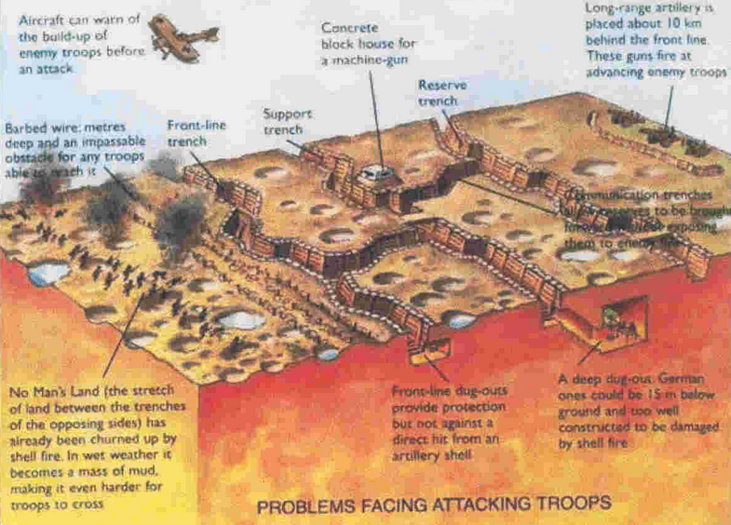
  - made on the battlefield.
D
A)
C
B
B)
A

C)
E
D)

E)
- Environment in the trenches
  - Constant
  - Flooding leads to
  - Filth includes
  - Frequent
  - Lack of
  - Little to no
- The First Modern War
  - What three new weapons earned WWI the title of “First Modern War”?
  - WWWI tactics , resulting in
    - casualties in WWI.
  - Calls for a change in
End of WWI
- Armistice
  - Definition:

  - Signed
  - Is the war officially over yet?
- Paris Peace Conference, 1919
  - Meeting of to set
  - How many countries were present?
  - What was President Woodrow Wilson’s “14 Points”?
  - What were the major outcomes of the conference?
- The League of Nations
  - An international organization created to
  - Mission was to
  - Did the league succeed in its mission?
- Treaty of Versailles
  - June 28th, 1919:
  - Central powers had in the treaty’s provisions.
  - Article 231, The War Guilt Clause, forced Germany to…
    - Accept
    - Pay
    - Completely
    - Give up
    - Replace
- Versailles Fallout
  - German economy
  - Rise of
  - and the Nazi Party.
  - Overthrow of the
  - Establishment of the
  - Outbreak of

